Project Design Phase-II
Data Flow Diagram & User Stories

Date | 15 Feb 2026
Team ID | LTVIP2026TMIDS52481
Project Name | Dog Breed Identification Using Transfer Learning
Maximum Marks | 4 Marks

Data Flow Diagrams:
A Data Flow Diagram (DFD) represents how data moves through the dog breed classification system, showing:
- How users upload images
- How the backend processes images
- How the trained MobileNetV2 model predicts the breed
- Where prediction results and history are stored
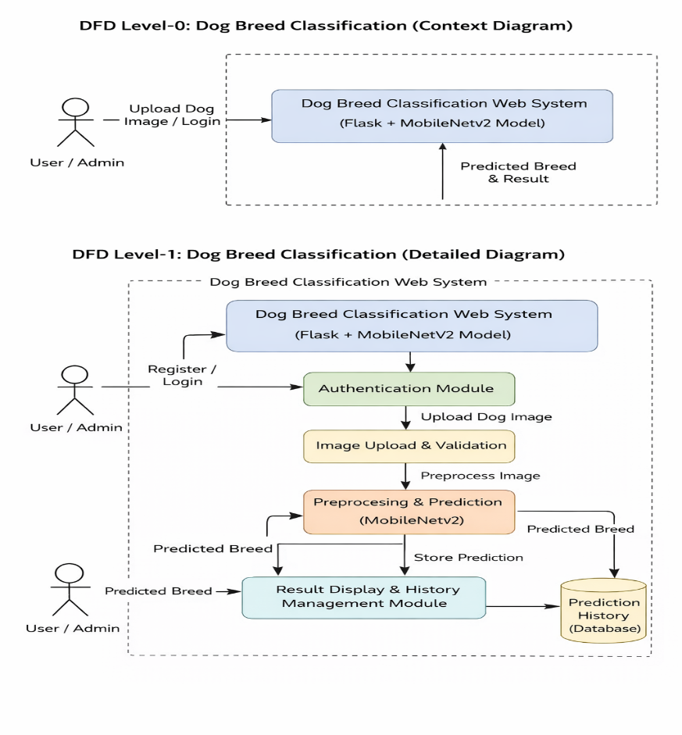

User Stories
User Type | Functional Requirement (Epic) | User Story Number | User Story / Task | Acceptance criteria | Priority | Release
Customer | Registration | USN-1 | As a user, I can register by entering my email, password | I can access my account / dashboard | High | Sprint-1
 |  | USN-2 | As a user, I can log into the system securely. | I can access prediction features after login. | High | Sprint-1
 |  | USN-3 | As a user, I can upload a dog image. | The system accepts valid image formats. | High | Sprint-1
 |  | USN-4 | As a user, I can view the predicted dog breed and confidence score. | As a user, I can view the predicted dog breed and confidence score. | High | Sprint-1
 |  | USN-5 | As a user, I can view my previous prediction history. | Past predictions are listed with timestamps. | Medium | Sprint-2
Customer (Web user) |  | USN-6 | As a user, I can temporarily clear my prediction history. | My history is hidden but stored for admin view. | Medium | Sprint-2

